2021

**Multi Stamping Project**



Kafrelsheikh University

Faculty of Artificial intelligence

**Multi Stamping Project**

**Supervised by:**

Dr / Tamer Medhat Dr/Ali Siam

Eng / Mona Elnagar

**Team members:**

**-Youssif Mohamed Adel -Younan Iskander Sorial**

**-Mahmoud Magdy Elnahal -Moustafa Mahmoud Elmoghazy**

**-Mina Samir tawfik -Mariam Ashraf**

**-Alaa Ayman El-kady -Mai Saeed Menisy**

**-Marwa Elsayed Khalil -Menna Mohamed Elshahat**

**-Rawan Hatem Ramadan -Eman Fathy Mansour**

**-Sara Mohamed Ahmed -Hala Mohamed Farouk**

**-Aliaa Ghanem Ali -Alaa Ahmed sabough**

**-Aml khaled elsharkawy -Fatma khairy Aboalatta**

**-Lamiaa ahmed abdelaziz -Meriham Khaled Hathot**

-**Eman AbdElhamed Khalifa -Menna Allah Mohamed**

**Content**

**Project’s name……..………………………………………………………………………… Page 1**

**2 Team ..…………………...……..……………………………………………….…………… Page Goal of this project ……………….………………………………………………………… Page 6 -3**

**4-introduction to the project …………………………………………………………….. Page 9**

**Components of the Project……………………………………………………………Page 10-15**

**6-Some of the problems we faced ……………………………………………..…… Page 16**

**7-IR Sensor vs. Ultrasonic Sensor…………………………………………….……… Page 17**

**8- servo motor vs. stepper motor…………………………………………….……… Page 18**

**9- TinkerCAD vs.fritzing……………………………………………..…………………… Page 19**

**10-Connection method……………………..……………………………………………… Page 20**

**11-The Circuit………………………………………………………………………………… Page 21**

**List of tools**

**Arduino uno………………………………………………….…… Page ( 10 ) Figure(1**

**IR sensor………………………………………………………….…,…Page ( 11) Figure(2**

**1PCS TB6560**:**…………………………………………………………Page ( 11) Figure(3**

**Wires …………………………………………………………………... Page ( 12) Figure(4**

**keypad ………………………………………………………..…………. Page ( 13) Figure(5**

**Breadboard…………………………………………………………….. Page ( 13) Figure(6**

**LCD,I2C ……………………………………………………………………Page ( 14 ) Figure(7 Stepper Motor…………………………………………………………Page ( 15 ) Figure(8**

**Adapter 12v…………………………………………………………..Page ( 15 ) Figure(9) Goal of this project**

**Why did we make this machine?**

**‐First of all the goal of this machine is:**

Counting the number of answer sheets and then stamping them. While the academic staff were counting and stamping the answer sheets, they took a lot of time, efforts and many working hands.

**-we made this machine to:**

Save the time ,effort, instead of three or four people counting and stamping answer sheets, this machine will do this task, besides having a little working hand, so we need human help but not like before.

-The need for human effort will be reduced, in addition to saving more time and then it’s the beginning of normalizing artificial intelligence in various academic fields to make life easier for academic staff.

**Current features:**

1‐ Having a keypad so we can put a password to limit its usage by anyone.

2- Counting answer sheets, Bubble sheets and determining the desired quantity.

**Recommendation:**

1‐ add a fingerprint to increase the accuracy.

2‐ put a moving belt to move paper to make this machine work without anyone (Automatically).

3- Put a device for counting the paper automatically.

4- Increase the number of arms.

5-Later development brings movable arm stamp machines.

**Introduction to multi stamping project**

-The stamping machine is one of the principal machines in the stamping industry & printing industry.

-The process of stamping was manual. It was a human-based operation that consists of a lot of mistakes and inaccuracies. That operation takes a lot of time and human effort.

-Its importance is to fabricate the machine at minimum cost and profitable output. Also, the machine is simple to maintain and easy to operate. Hence to attempt this needs, fabrication of an automatic stamping machine is needed.

-The stamping mechanism of paper is useful in many kinds of organizations**.**

**-The machine can be used in:**

**- Universities**

**- Government offices**

**- Post offices**

**- Banks**

**- Collages**.

**Components of the Project**

**ARDUINO:** it takes all kind of data, like temperature or intensity, and it controls motors, LEDs and many other electronic parts.

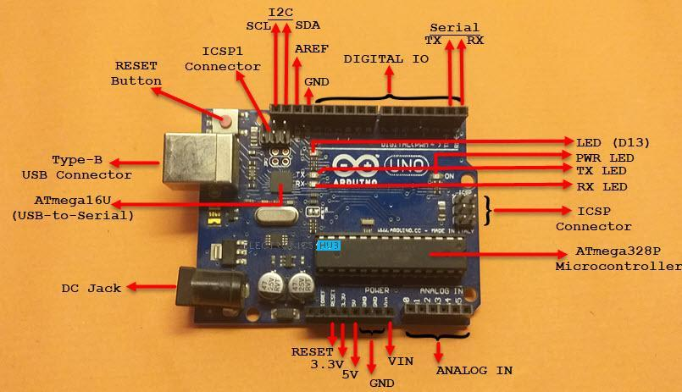

**IR SENSOR** : REMOTE EQUIPMENT CONTROL by heat

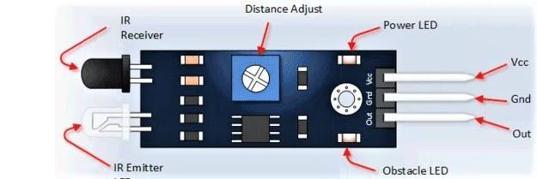

**Figure (2)**

**1PCS TB6560:**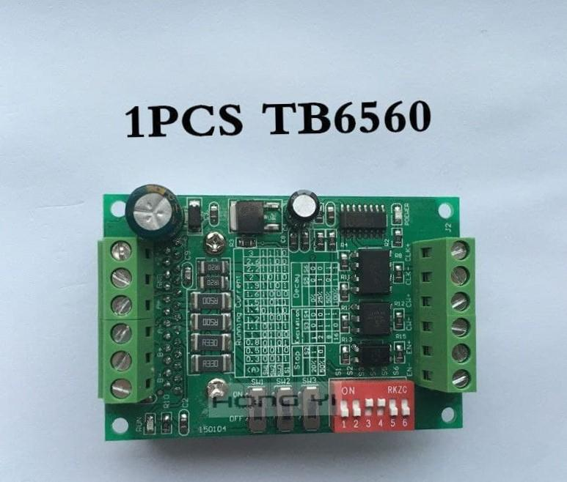



**.WIRES:** conduct electricity.

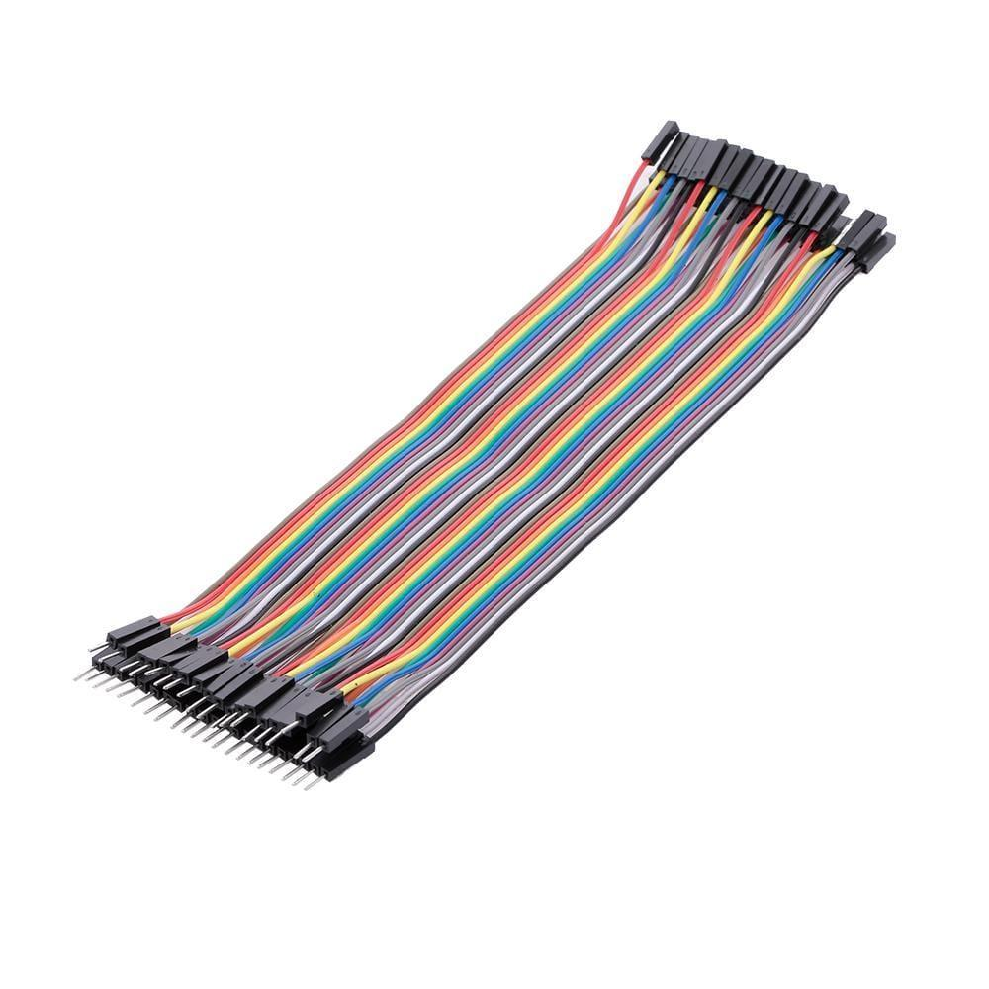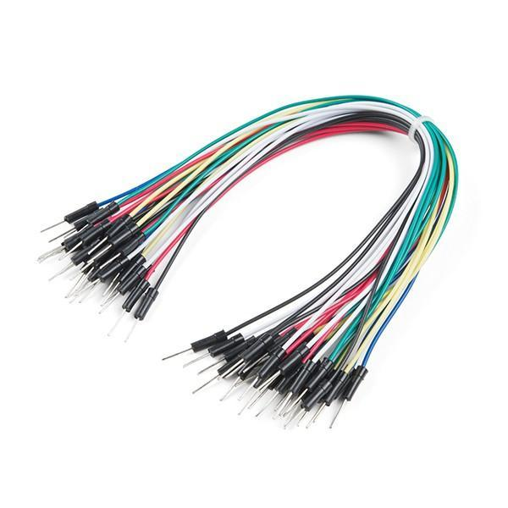

**Figure (4)**

**Keypad:** It can enter numbers and codes and control many

different applications, like math and security …etc.

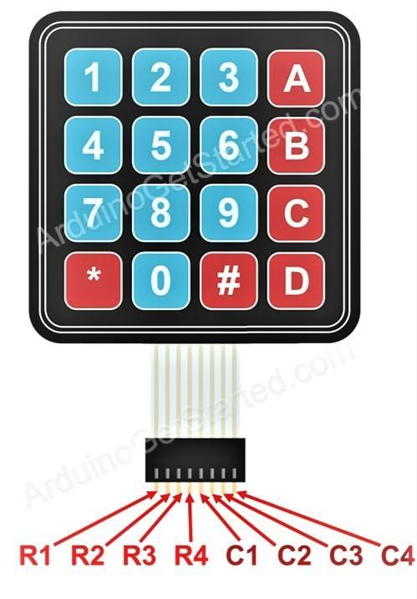.

**Figure (5)**

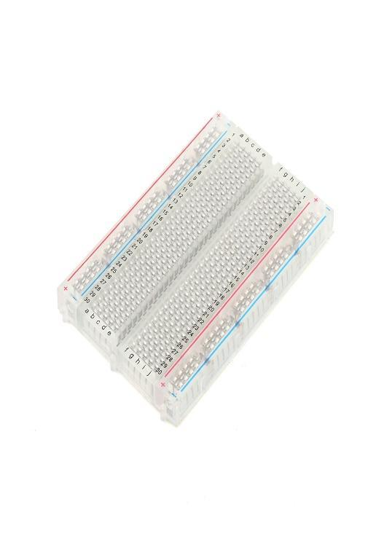**Breadboard**: is a rectangular plastic board with a bunch of tiny holes in it. These holes let you easily insert electronic components to prototype



. **Lcd with i2c:** is ideal for displaying text and numbers and special characters. LCDs incorporate a small add-on circuit (backpack) mounted on the back of the LCD module.

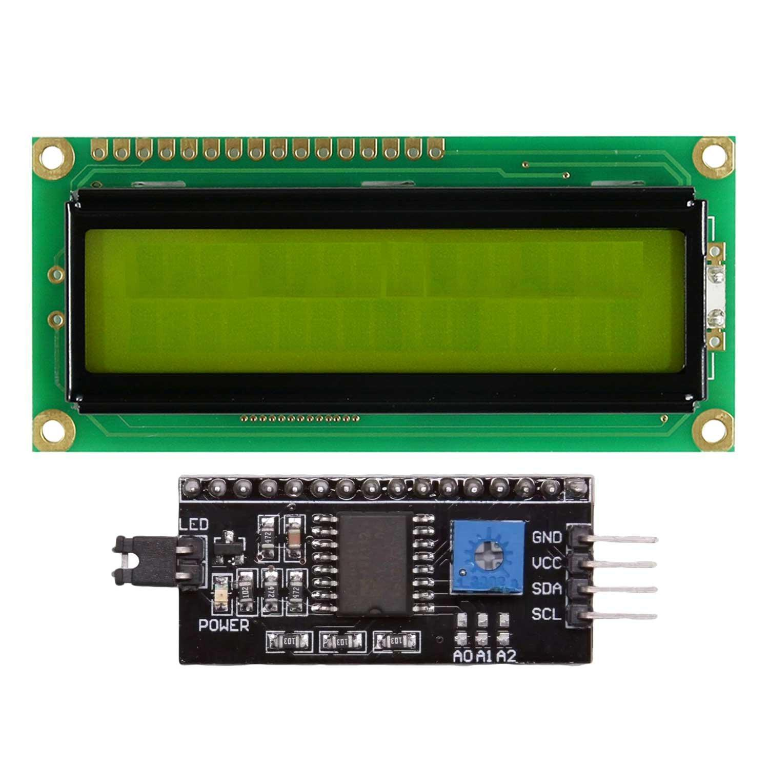



**STEPPER MOTOR (nema 23):** it can precisely control the number and speed of its revolutions and stop angle Because it can be controlled to stop at a certain angle.

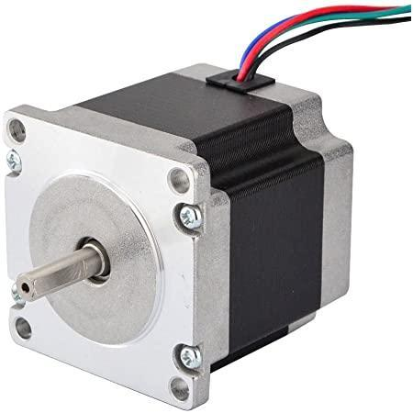

**Figure (8)**

**Adapter 12 v:** A power supply performs the job of providing power to a battery run device, while also adapting the power coming from the mains power point to the appropriate voltage.

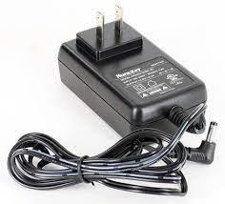

**Some of the problems we faced:**

-we have to design the project vertically not horizontally.

**Why is it designed vertically?**

The project is designed vertically to distribute pressure and not focus on a specific area because this will lead to damage to the device and fail its mission.

Imagine if the device is designed horizontally, there will be pressure on the sides and damage the paper.

Besides, you will not be able to sign a specific area when placing it horizontally, because this will put pressure on the parties without signing the area you want.

-**What if it is tilted?**

**-Do you think that will help you?**

of course not. Because basically you won't be able to sign papers in that way because the stamp will not be able to descend in the correct way. the basic shape of the stamp is vertical so you will not stamp the paper in the first places and the device will not do its job

**IR Sensor vs. Ultrasonic Sensor**

**What is the difference?**

The biggest difference between IR sensor and ultrasonic sensors is the way in which the sensor works. Ultrasonic sensors use sound waves (echolocation) to measure how far you are from an object. On the other hand, IR sensors use Infrared light to determine whether an object is present or not.

Accuracy and reliability are also different in these sensors. Most often, ultrasonic sensors will provide you more reliable and accurate data than IR sensors. If you want an accurate, numerical representation of distance for your project, the best choice is an Ultrasonic sensor.

However, if you only need to know if an object is present or not, then an IR sensor is the best.

**Servo motor vs. stepper motor**

**What is the difference?**

Differences in Servo Motors and Stepper Motors for Motion Control Applications:

The main difference between these motors comes from the overall pole count. Stepper motors have a high pole count, usually between 50 and 100. Servo motors have a low pole count – between 4 and 12.

This difference in pole count means that stepper motors move incrementally with a consistent pulse in a closed loop system. Servo motors require an encoder to adjust pulses for position control.

**We used Fritzing in the design and did not use Tinkercad and this is a comparison to show why we preferred Fritzing**

**TinkerCAD**



Tinker cad is: a free-of-charge, online 3D modeling program that runs in a web browser. Since it became available in 2011 it has become a popular platform for creating models for 3D printing as well as an entry-level introduction to constructive solid geometry in schools.

**Fritzing**



Fritzing Is: an open-source initiative to develop amateur or hobby CAD software for the design of electronics hardware and artists ready to 

